NIR TO RGB VIDEO COLOURIZATION
with Temporal Consistency Enhancement for Edge Deployment

Dataset details
S. No. | Dataset | Link | Details | Dataset Exploration | Sample image Details
1 | IDD-AW | https://idd.insaan.iiit.ac.in/dataset/download/ | Adverse-weather Indian driving dataset for autonomous driving research. | • 5000 RGB-NIR pairs  • Resolution: 1024 x 1024  • Weather: rain, fog, low-light  • Scenes: urban roads, highways  • Annotated for scene understanding | Driving scenes captured under adverse weather conditions such as rain, fog, snow, and low-light environments. Contains roads, vehicles, pedestrians, and roadside infrastructure with paired RGB and NIR images.
2 | OMSIV/SSMID | https://drive.google.com/file/d/1KDi-JJLgMeM6iVN6WXbsAxSzL-_6lIJv/view | Paired RGB-NIR dataset for image translation and fusion. | • 500 RGB-NIR pairs  • 800 train, 200 test  • Resolution: 580 x 320  • Indoor/outdoor scenes  • Well-aligned RGB-NIR images | Urban outdoor scenes containing buildings, roads, and vegetation. RGB–NIR image pairs are well aligned, with vegetation appearing brighter in NIR images.
2 | RANUS | https://drive.google.com/file/d/1WJ7rcCeMBPy9Qb2c_pwI0rUIlFqotkzT/view  (not complete, only 4000 images) | RGB-NIR urban scene dataset for cross-spectral learning. | • ~4000 paired images  • Classes: 22  • Urban environments  • Roads, buildings, vehicles  • Good RGB-NIR correspondence | Urban road scenes with trees, sidewalks, vehicles, and street infrastructure. RGB–NIR image pairs are well aligned, and vegetation appears brighter in NIR images. Semantic segmentation masks are also provided.

1. RANUS RGB–NIR Urban Scene Dataset
2. Pixel-aligned RGB–NIR Stereo Dataset – use this primarily for training https://github.com/divisonofficer/Pixel_aligned_RGB_NIR_Stereo - has vision/depth-estimation dataset and benchmark, so the reported metrics are depth-related (RMSE, disparity error, etc.) rather than image-quality metrics like PSNR, SSIM, LPIPS, or FID.
Check

Take the FLAIC Net Model code from Sarthak and apply over the video and if getting some issue, just ask asap.

Go with the Sarthak point of view as he is proposing 4 ideas to work on these Dataset
Plz check which of the following methods is faster? Whether we can adopt the strategy in our work?
- VOS: Towards thermal infrared image colorization via View Overlap Strategy
- NTIRE 2023 Video Colorization Challenge
- BiSTNet: Semantic Image Prior Guided Bidirectional Temporal Feature Fusion for Deep Exemplar-Based Video Colorization

Model | RANUS |  |  | Pixel-aligned
Model | PSNR | SSIM | LPIPS | PSNR | SSIM | LPIPS
U-Net / Pix2Pix | 15.8891 | 0.6492 | 0.3465
FLAIC | 19.6730 | 0.5924 | 0.2674 | 31.1798 | 0.8986 | 0.1645
HAQAGen | 18.59 | 0.7757 | 0.2964
SF-GPT | 20.6616 | 0.8151 | 0.3556
ColorMamba | 15.3391 | 0.5637 | 0.6157

Flaic- =======================================================

TEST SET RESULTS (664 images)

=======================================================

PSNR : 19.5442 _ 5.1379

SSIM : 0.5894 _ 0.2111

LPIPS : 0.2666 _ 0.0836

Dataset comparison
Dataset | Data Type | RGB-NIR Pairing | Environment | Strengths | Limitations
RANUS | RGB-NIR image pairs | Paired | Outdoor scenes under varying illumination | Good diversity of natural scenes and lighting conditions; useful for learning robust NIR-to-RGB mappings | Limited temporal information, very less images
Pixel-Aligned RGB-NIR Stereo | Pixel-aligned RGB-NIR pairs | Precisely paired | Indoor and outdoor scenes | High-quality alignment between RGB and NIR images; suitable for supervised colorization training and quantitative evaluation | Smaller diversity compared to larger datasets, dark images
IDDAW | RGB-NIR image pairs | Paired | Driving and real-world outdoor environments | Provides challenging scenes with varying weather, illumination, and object categories; improves generalization | Contains more complex scenes that may increase training difficulty, image quality not good

IDDAW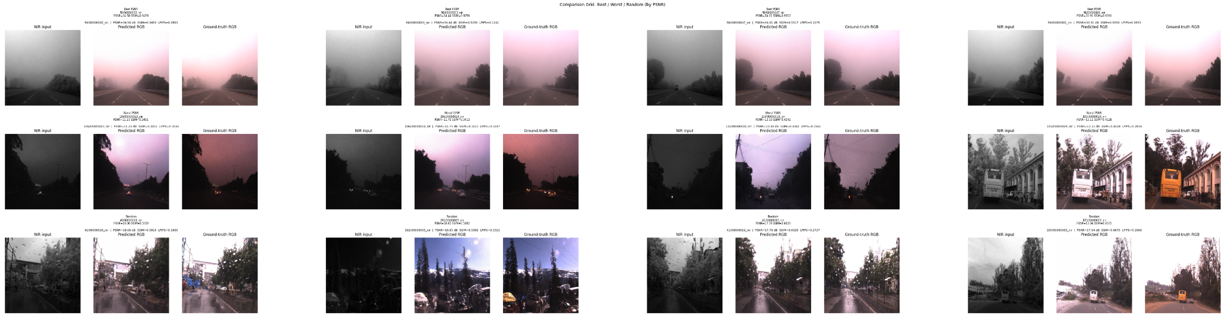PIXEL ALIGNED
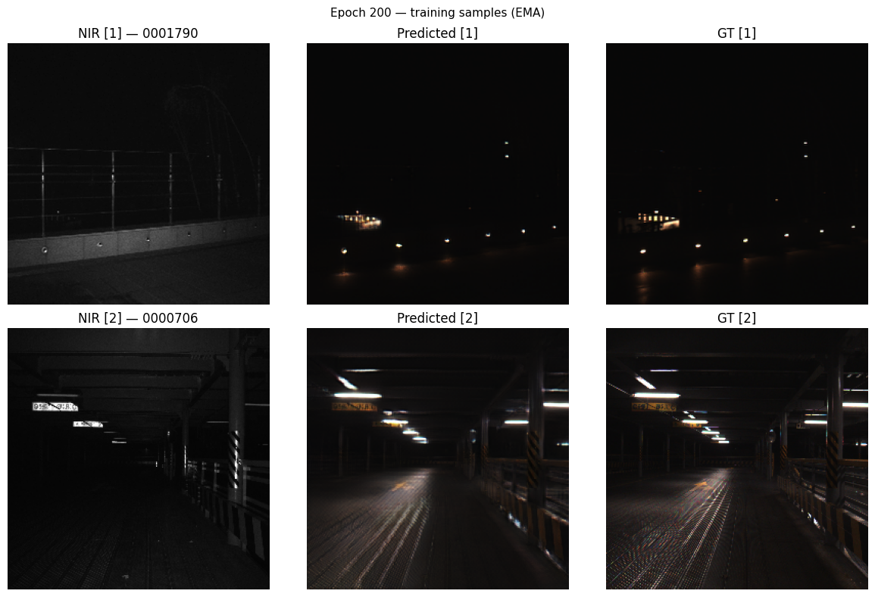
RANUS
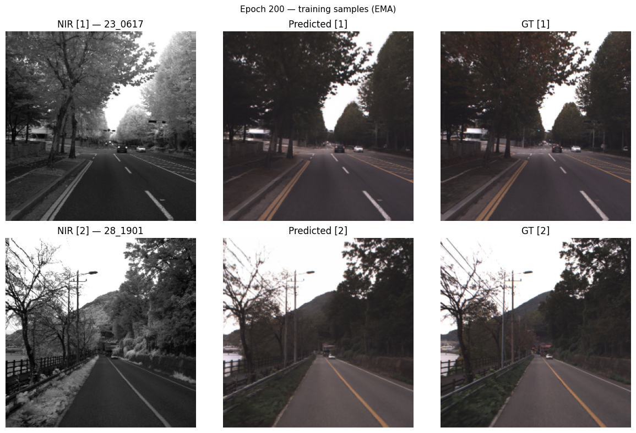

Literature Reviews
Image Colorization
Traditional image colorization approaches:
- User-guided color propagation.
- Optimization-based color transfer.
Limitations:
- Require human interaction.
- Not suitable for automated video processing.
Deep Learning-Based Colorization
Notable approaches:
- Pix2Pix
- CycleGAN
- Conditional GANs
- U-Net based image translation models
Advantages:
- End-to-end learning.
- Better semantic understanding.
- Realistic color generation.
Limitations:
- Designed primarily for images.
- Temporal consistency not considered.
Infrared-to-Visible Translation
Recent works:
- IR2VI
- ThermalGAN
- GAN-based multispectral image translation
Advantages:
- Generate visible-spectrum images from infrared inputs.
Limitations:
- Temporal flickering in video applications.
- High computational requirements.
- Limited suitability for edge devices.
Video Colorization and Temporal Consistency
Modern methods employ:
- Optical flow.
- Recurrent architectures.
- Temporal attention.
- Feature propagation.
Challenges:
- Increased computational complexity.
- Memory overhead.
- Difficult real-time deployment.
Reference-Driven Contrastive Thermal IR Colorization (2025) – improved color realism and feature preservation | Flower dataset
This framework performs thermal infrared-to-RGB colorization using a dual-encoder architecture, where a reference RGB image guides the colorization process. It improves color realism and detail preservation through the Multi-Receptive Field Feature Integration Module (MFIM) for multi-scale feature extraction, the Improved Stop-Gradient Attention (ISGA) module for reference-guided color transfer, and the Channel–Spatial Feature Enhancement Module (CSFEM) for adaptive attention.
The model is further optimized using contrastive learning, perceptual loss, and style loss to generate more realistic RGB outputs. For our FLAIC-based NIR-to-RGB system, the MFIM, CSFEM, and contrastive learning strategies could be incorporated to improve texture preservation, feature representation, and perceptual quality. However, the method is designed for single-image colorization, relies on a reference RGB image, and does not address temporal consistency, flicker reduction, or video processing.
HAQAGen (2026) - Checks color distribution match | KAIST dataset - pedestrian dataset
HAQAGen is a NIR-to-RGB colorization framework that improves color realism and texture preservation using histogram-based color alignment,
HSV-guided color priors, - hue, saturation- random color shift avoided
and perceptual feature losses. It also supports adaptive-resolution inference for high-resolution images. For our FLAIC model, the histogram loss and HSV auxiliary branch could be incorporated to improve color consistency and generate more realistic RGB outputs. However, the method does not address temporal consistency and is designed primarily for image colorization.
TCVC (2021) - stability of colors over time
TCVC is a video colorization framework that focuses on reducing flickering and improving temporal consistency through bidirectional feature propagation (uses t-1, t, t+1) and temporal self-regularization (loss if colours not matching). Its feature propagation and temporal loss mechanisms are highly relevant to our FLAIC-based video colorization system. These ideas can be combined with Gated Temporal Feature Memory to produce smoother and more stable NIR-to-RGB video outputs.
Application to FLAIC
HAQAGen contributes better color quality and texture preservation, while TCVC contributes better temporal consistency. Combining these ideas with FLAIC can improve both visual realism and video stability.

Paper | Main Focus | Advantages | Limitations | Relevance
HAQAGen | NIR→RGB color realism and texture preservation | Histogram loss, HSV priors, adaptive resolution | No temporal modeling | Medium
TCVC | Temporal consistency in video colorization | Feature propagation, temporal loss, flicker reduction | Requires optical flow, not NIR-specific | Very High
FLAIC | Feature-level NIR→RGB translation | Lightweight, strong spatial colorization | Frame-wise only | Base model
Gated Temporal Feature Memory | Video consistency | Temporal memory without heavy optical flow | Needs sequential data | Very High

Research Gap Identified
Existing NIR-to-RGB methods focus primarily on image-level translation.
Major limitations:
- Temporal consistency is often ignored.
- Frame-by-frame colorization causes flickering.
- Computationally expensive architectures hinder deployment on embedded hardware.
- Existing video approaches often rely on optical flow, increasing latency.
- Limited work combines temporal consistency with edge deployment constraints.
Therefore, there is a need for a lightweight NIR-to-RGB video colorization framework capable of producing temporally stable outputs while remaining deployable on devices such as Jetson Nano.

Establish that frame-wise translation flickers
Results
ALL OBTAINED RESULTS(including images and video) ARE IN THIS DRIVE FILE - https://drive.google.com/drive/folders/1IJE1cQgZSKVT1Agiim1aM2pA78ybrB4D?usp=sharing

Run the best image model frame-by-frame over true NIR videos.
*ALL OF THE FOLLOWING METRICS ARE FOR THE IDD-AW DATASET*
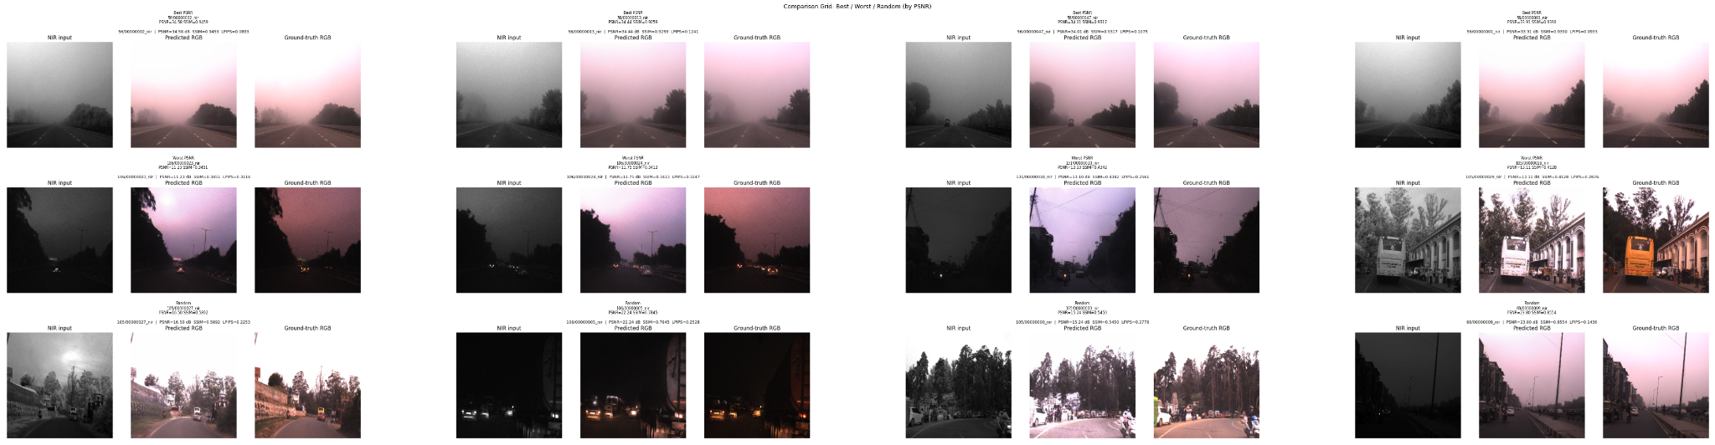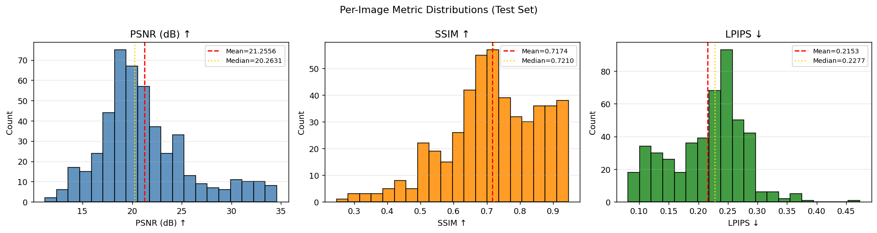

Model | PSNR ↑ | SSIM ↑ | LPIPS ↓ | Temporal Warping Error ↓ | Flicker Index ↓ | FPS ↑
Frame-wise FLAIC | 21.2556 | 0.7174 | 0.2153 | 50.2943 | 17.7086 | 71.05

FLAIC + Adaptive Alpha Blending

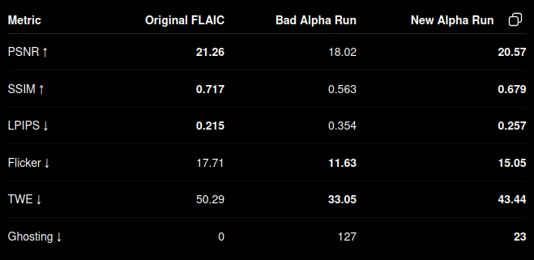
The above table is a comparison between initial run and then running after making a fix - changing the blended function. Initial ghosting was over 100, the change has brought it down to 23.
Adaptive alpha blending was modified from: $α_{t}=min(1, \frac{(Δt)}{τ})$
To $α_{t}=clip(\frac{Δt}{τ}, 0.8, 1.0)$
so that at least 80% of the output comes from the current frame. This reduces excessive dependence on previous frames, significantly lowering ghosting while still providing temporal smoothing to reduce flicker.
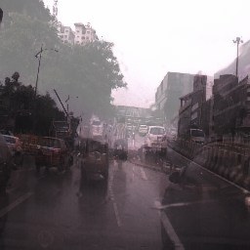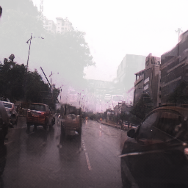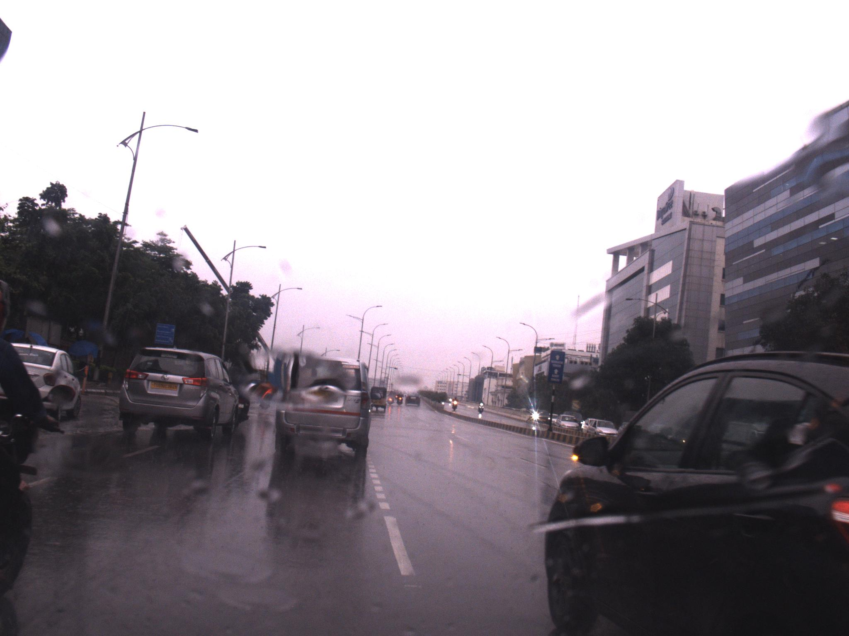
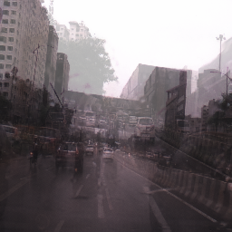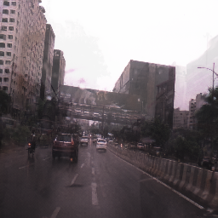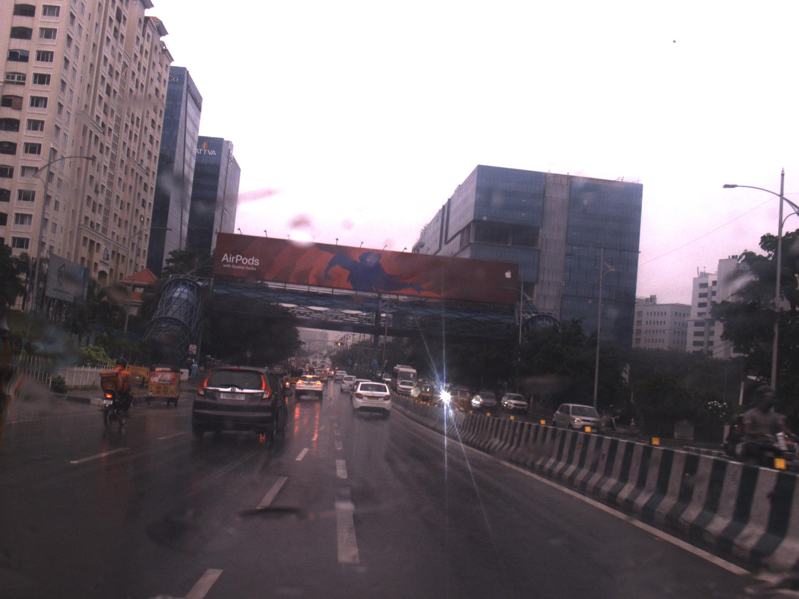
Model | PSNR ↑ | SSIM ↑ | LPIPS ↓ | Flicker ↓ | Ghosting cases | FPS ↑
Frame-wise FLAIC | 21.2556 | 0.7174 | 0.2153 | 17.7086 | 0 | 70.84
FLAIC + Alpha Blend | 20.5683 | 0.6788 | 0.2571 | 15.0510 | 23 | 57

FLAIC + Gated Temporal Feature Memory

Model | PSNR ↑ | LPIPS ↓ | Flicker ↓ | tLPIPS ↓ | Color Drift ↓ | InferenceFPS ↑
Frame-wise FLAIC | 21.2556 | 0.2153 | 17.7086 | 0.4748 | 27.3371 | 69.70
FLAIC+Alpha Blend | 20.5683 | 0.2571 | 15.0510 | 0.4140 | 23.8277 | 57
Previous RGB Conditioning | 22.1436 | 0.2119 | 16.9177 | 0.4797 | 5.3149 | 54.64
Direct Feature Injection | 21.2556 | 0.2153 | 17.4642 | 0.4772 | 5.4503 | 57.83
Gated Temporal Memory - Ours | 21.1791 | 0.2160 | 16.8850 | 0.4686 | 21.5285 | 46.82

Tempnir2rgb
Metrics | Average
Total Loss | 0.077072
L1 Loss | 0.053066
LPIPS Loss | 0.158979
Temporal Loss | 0.081082
Gate Value | 0.096403
Other metrics to be calculated since inference yet to be done

MODEL DETAILS:
Model | Retraining | Main Idea
Original FLAIC | No | Baseline single-frame RGB colorization from NIR and wavelet features.
Adaptive Alpha Blending | No | Post-processing temporal smoothing by blending current and previous outputs using an adaptive α based on frame differences. Smooths the video by blending the current prediction with the previous output. When the scene changes little, more information is carried over from the previous frame to reduce flicker.
Previous RGB Conditioning | Yes for the RGB channels | Extends FLAIC from 8 to 11 input channels by feeding the previous RGB prediction, with an additional temporal consistency loss during training. Gives the network access to the previously predicted RGB frame so it can learn to maintain consistent colors across consecutive frames.
Gated Temporal Feature Memory | No | Reuses bottleneck features from the previous frame through adaptive gating, providing semantic temporal memory without pixel-level copying. Allows the network to remember high-level information from the previous frame (such as road, sky, or building appearance) and use it when colorizing the current frame.
Bottleneck Residual Injection | No | Refined version of temporal feature memory using cached bottleneck features, additive residual injection, stop-gradient, and adaptive gating. A refined memory-based approach that injects useful features from the previous frame into the current prediction, improving temporal consistency while avoiding excessive blur or ghosting.

Sample images
FLAIC basemodel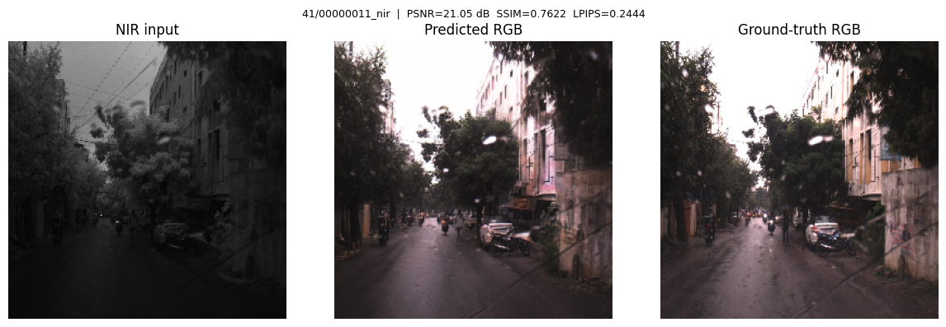
Alpha blending
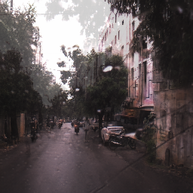
RGB Conditioning
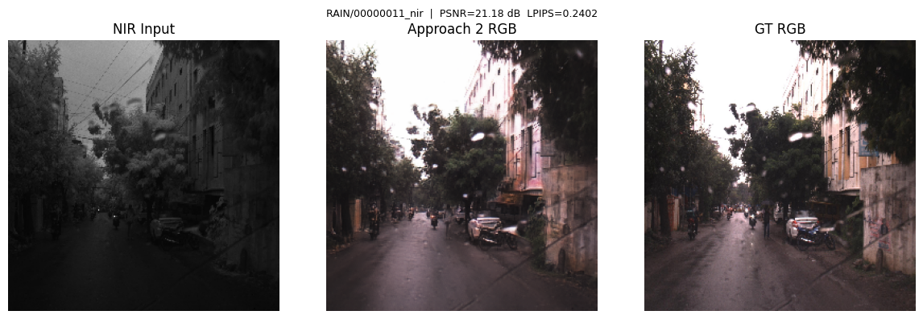
Feature injection
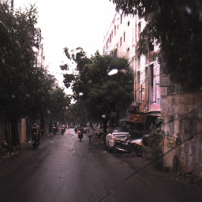
Gated temporal memory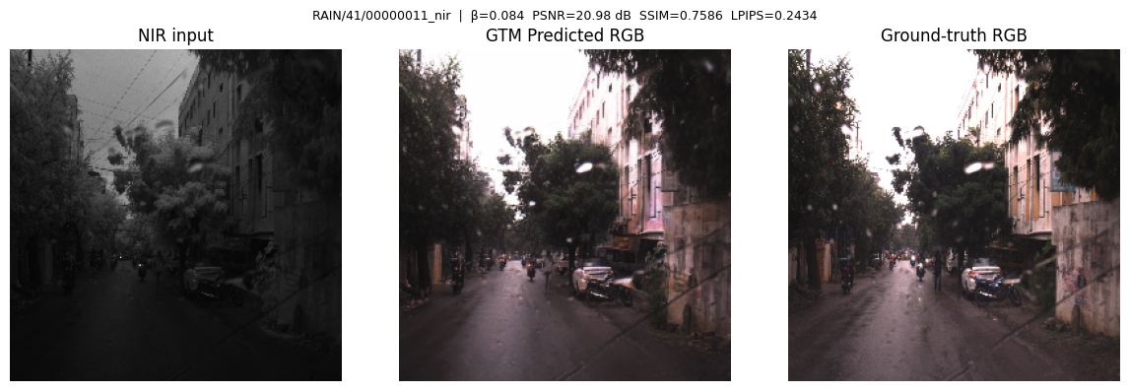
Onnx import for RGB Conditioning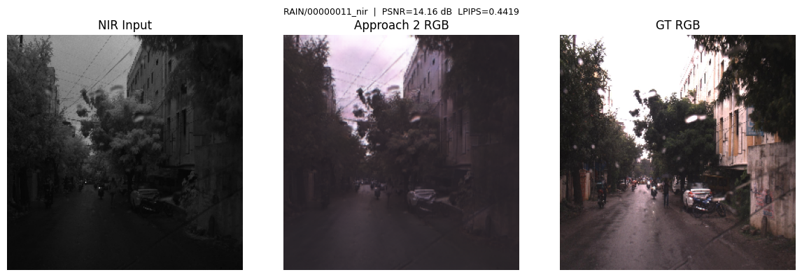
Onnx FP32 import for GTM (62 MB)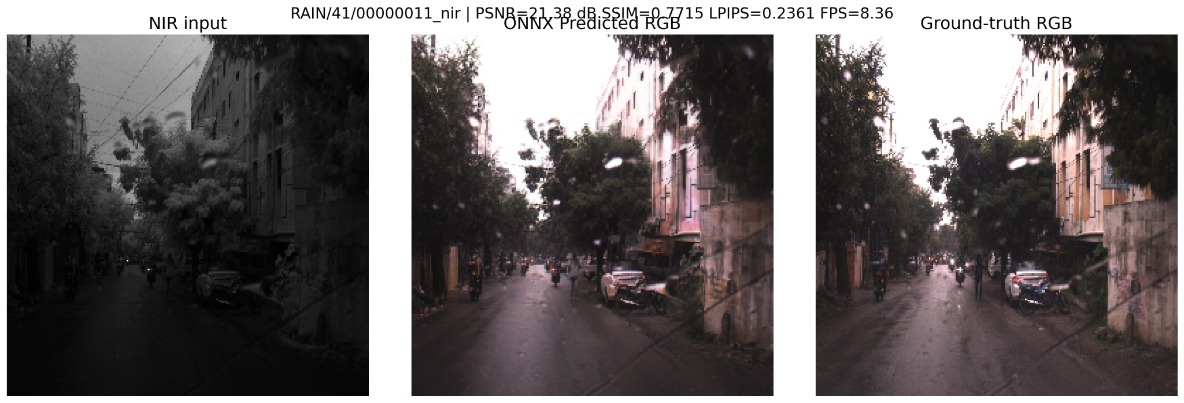
Onnx FP16 import for GTM (31MB)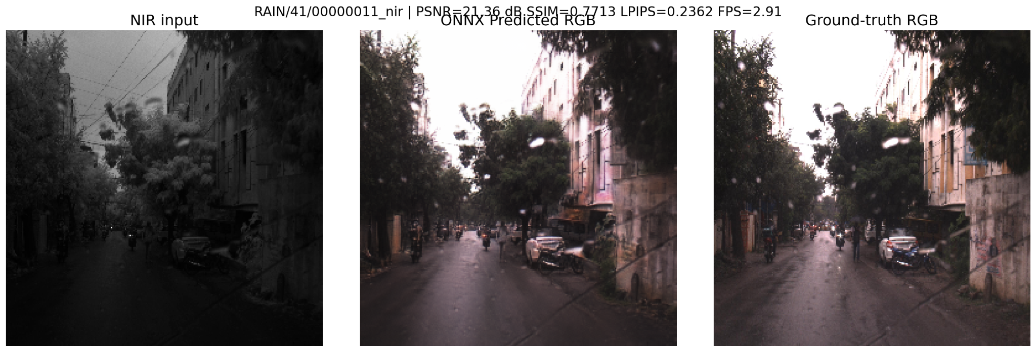

Inference time for all models

Model | Inference time
Frame-wise FLAIC | 14.35 ms
FLAIC + Alpha Blend | 17.54 ms
Previous RGB Conditioning | 18.30 ms
Direct Feature Injection | 17.29 ms
Gated Temporal Memory | 21.36 ms (on mps)
Gated Temporal Memory (FP32) | 116.3 ms (on mps), 16.61ms (on cuda)
Gated Temporal Memory (FP16) | 386.10 ms (on mps)

ONNX Deployment Evaluation
ONNX FP32 Results
Metric | Value
PSNR | 21.01 dB
SSIM | 0.7183
LPIPS | 0.2071
FPS | 8.62 (mps), 60 (cuda)
Inference Time | 116.26 ms/frame, 16.61ms (on cuda)
Model Size | 61.53 MB
RAM Usage | 1.62 GB
Analysis
The ONNX model preserved the colorization quality of the original checkpoint, with only minor differences in PSNR, SSIM, and LPIPS. This indicates that the model export process was successful and did not significantly degrade reconstruction quality.
However, the measured throughput (8.62 FPS) was substantially lower than the original Gated Temporal Memory implementation (21.37 FPS).
Bottleneck Investigation
To identify the source of the slowdown, runtime profiling was performed.
Component | Time
Preprocessing | 4.27 ms
Image Saving | 2.19 ms
ONNX Inference | 116.26 ms
Results showed that more than 95% of the execution time was spent inside the ONNX model inference itself. Preprocessing and image I/O contributed only a small fraction of the total runtime.
Why FPS Decreased
Although the original Gated Temporal Memory implementation achieved 21.37 FPS, the ONNX version achieved 8.62 FPS on Apple Silicon. This reduction is mainly due to differences in execution backends rather than a loss in model quality.
The original benchmark was performed using PyTorch with Apple's Metal Performance Shaders (MPS), which is highly optimized for PyTorch operations. In contrast, ONNX inference was executed through ONNX Runtime with the CoreML Execution Provider. While CoreML utilizes Apple hardware acceleration, some network operators may not be fully optimized and may partially fall back to less efficient execution paths. This results in higher latency despite identical network weights.
Future optimization steps include:
The ONNX evaluation confirms that the model can be successfully exported and deployed while maintaining colorization quality. However, further optimization is required to achieve real-time performance on embedded hardware.
Future deployment optimizations include:
- FP16 precision conversion to reduce memory usage and improve throughput.
- TensorRT acceleration on Jetson Nano for hardware-specific optimization and kernel fusion.
- TempNIR2RGB lightweight temporal memory architecture to provide temporal consistency with lower computational overhead.
- Model compression, pruning, and quantization to further reduce latency and memory consumption.
Inference for tempnir2rgb (no retrain) done
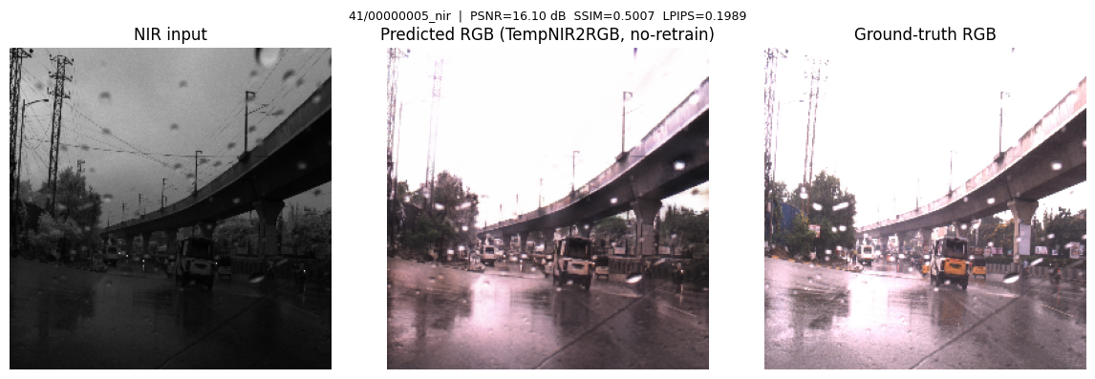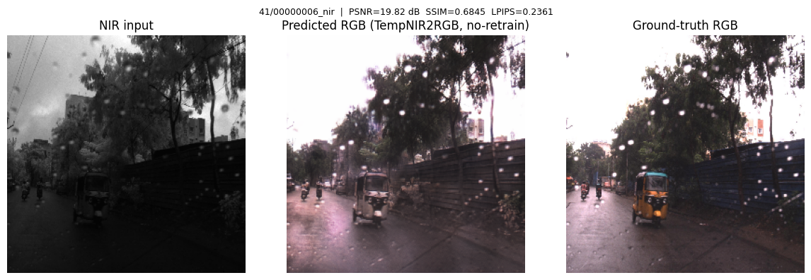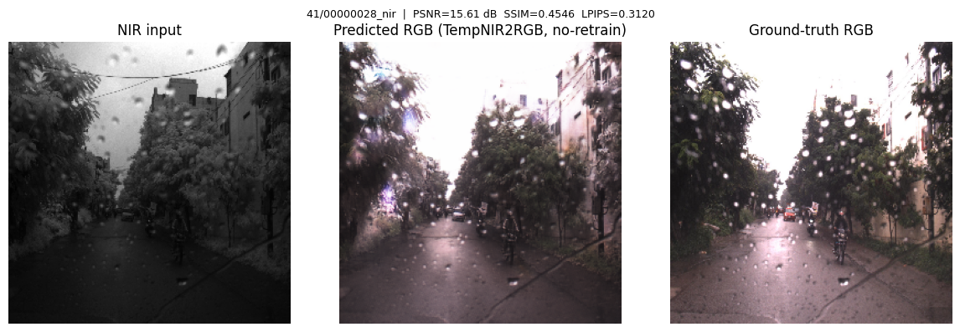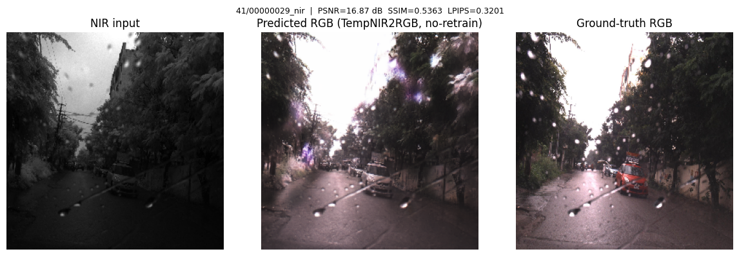

TempNir2RGB
Sample images:
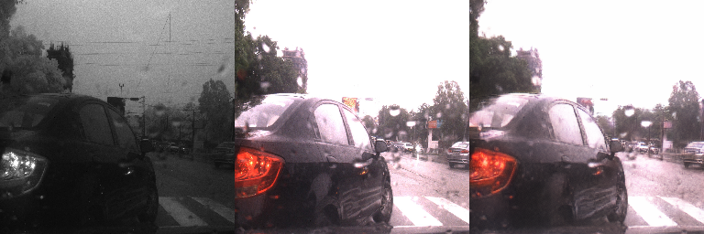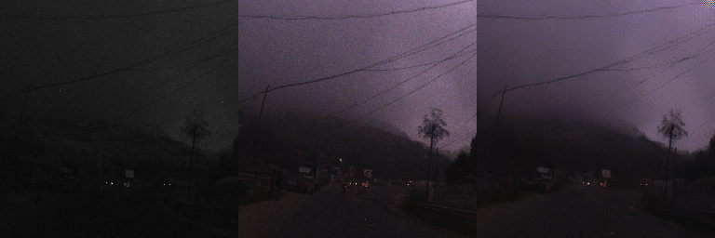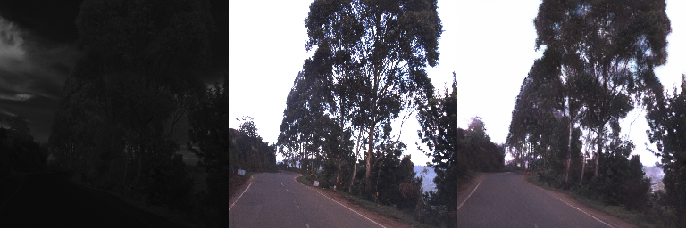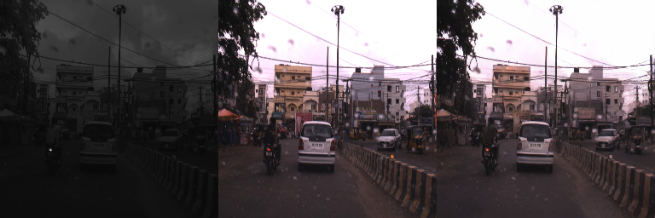

LPIPS Loss | 0.158979

Temporal Loss | 0.081082

Inference to be done
Work Completed So Far
- Dataset preprocessing
- Baseline NIR-to-RGB model implementation
- Training and validation
- Temporal consistency analysis
- Gated Temporal Feature Fusion implementation
- FLAIC integration experiments
- Metric evaluation
- ONNX export for RGB conditioning model and gated temporal model
- Inference benchmarking
- Deployment preparation for Jetson Nano

Goals Till Friday
- Implement the modified gated temporal method(HAQA + TCVC), VOS - need GPU for training, training has to be done since it is a different model and current checkpoints don't have the necessary weights.
- Inference on that.
- Export final model to ONNX.

Upcoming Goals
- Complete evaluation of FLAIC variants and benchmarks on the RANUS, Pixel-Aligned dataset.
- Create .engine file on the jetson
- Ablation study
- Deploy model on Jetson Nano.
- Measure FPS, latency, and memory usage.
- TensorRT conversion.
- Performance optimization.
- Model compression and pruning.
- Memory reduction.

Ablation Study

Variant | Frequency branch | Temporal memory | Learned gate | Flow loss during training | PSNR ↑ | LPIPS ↓ | Flicker ↓ | FPS ↑
Frame-wise backbone | Yes | No | No | No
+ Alpha blending | Yes | Output only | No | No
+ Previous RGB input | Yes | RGB feedback | No | No
+ Direct bottleneck injection | Yes | Yes | No | No
+ Gated temporal memory | Yes | Yes | Yes | No
+ Gated temporal memory + temporal loss | Yes | Yes | Yes | Yes

After this try this idea:
TempNIR2RGB: Causal Feature-Memory Translation for Real-Time Flicker-Free NIR-to-RGB Video
Keep the spatial-frequency strength of your frame-wise NIR→RGB model, but add a small trainable temporal module at feature level.
Instead of:
use:
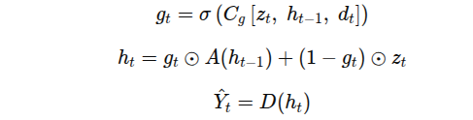
where:
- ztz_tzt​: current NIR encoded feature,
- ht−1h_{t-1}ht−1​: previous temporal memory,
- dtd_tdt​: downsampled NIR frame-change map,
- gtg_tgt​: learned confidence gate,
- A(⋅)A(\cdot)A(⋅): lightweight local alignment/refinement module,
- D(⋅)D(\cdot)D(⋅): RGB decoder.
The model learns:
- when to preserve previous color decisions,
- when to ignore previous memory because motion occurred,
- how to avoid color drift,
- how to remain causal and real-time.
INCLUDE THE RESULTING IMAGES, DATASET IMAGES

Model:

TempNIR2RGB-Lite: Change-Aware Causal Feature Memory for Real-Time NIR-to-RGB Video Colorization

These are correct and must be followed:
- Use FLAIC as frame-wise baseline.
- Use TempNIR2RGB-style causal feature memory as final method.
- Use change map + gate + local alignment to avoid flicker and ghosting.
- Evaluate on real ordered sequences.
- Split train/val/test by sequence, not by random frames.
- Run full test set evaluation.
- Report PSNR, SSIM, LPIPS, Flicker Index, Temporal Warping Error, tLPIPS, Color Drift, Ghosting Cases, FPS, latency, model size, params, FLOPs, GPU memory, RAM.
- Export ONNX and TensorRT.
- Measure batch-size-1 latency on desktop GPU and Jetson.
All missing:
Missing item | Status
Sequence-level dataset verification | DONE
manifest_sequences.csv | DONE
Full IDD-AW full-test evaluation | DONE
Full TempNIR2RGB training | DONE
Full TempNIR2RGB inference metrics | TO BE RUN
Ablation table | TO BE RUN
Weather-wise results: rain/fog/low-light | TO BE RUN
Cross-dataset RANUS test | TO BE RUN
Pixel-Aligned image-quality test | TO BE RUN
TensorRT FP16 engine | TO BE RUN
Jetson benchmark | TO BE RUN
Paper figures and qualitative videos | TO BE RUN

- Runtime, quality -lpips, ssim
- Mix up strategy -overlapping regions
Architecture:
The encoder and decoder are almost unchanged.
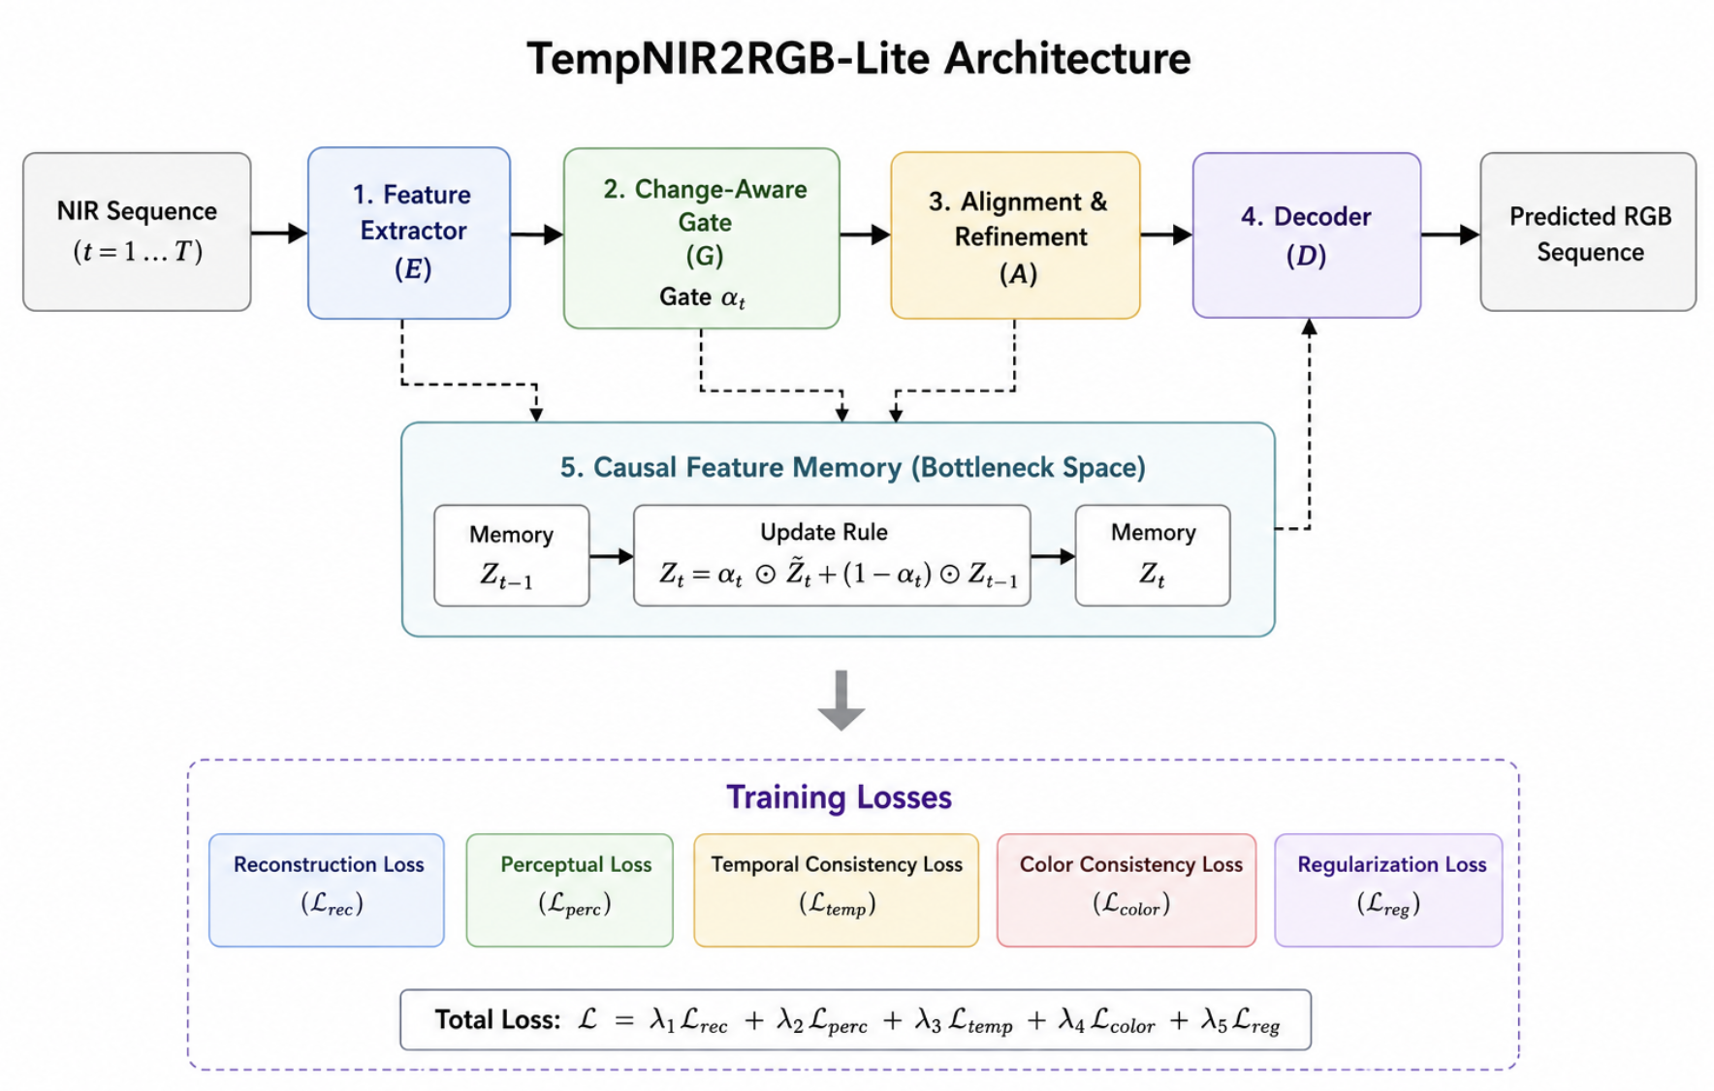
Question: Are the losses done at every step or are they computed at the end?
Component 1
Wavelet Branch. Adds high-frequency edge information.
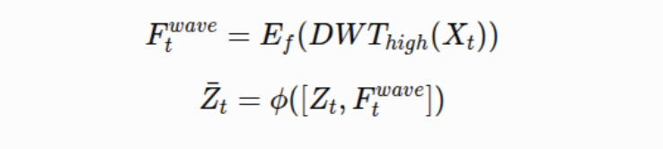
Improves
- lane markings
- vehicle boundaries
- textures
without changing the encoder.
Component 2
Feature Memory. Instead of forgetting everything, the model stores
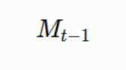
which contains information from previous frames.
Component 3
Change Map. Computes
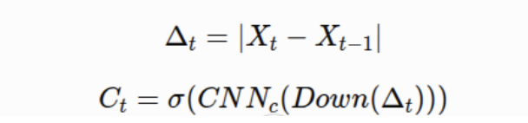
to detect where the image changed.
Component 4
Learned Gate. Learns how much of the current feature should replace previous memory.
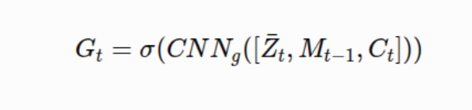
Component 5
Local Alignment. Instead of optical flow, uses a tiny CNN to align previous memory.
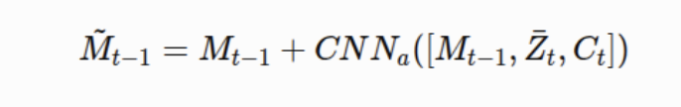

Component 6
Memory Update. Combines old memory and current feature using:
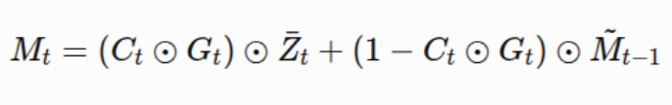
Losses
L1 loss - compares predicted to ground rgb
LPIPS - are they visually identical or not?
SSIM - same structure or not - brightness, contrast, structure
TWE
Flicker loss - if predicted dint change, then gt shouldnt change, penalty on change
Color loss - measured independently from brightness using Lab
HSV - hue, saturation, value | makes color comparison meaningful, temporal loss in stable regions - penalised
Gate regularization - gate and change map should agree

Final model

TempNIR2RGB-Lite: Change-Aware Causal Feature Memory for Real-Time NIR-to-RGB Video Colorization
A lightweight causal NIR-to-RGB video colorization model that stabilizes RGB predictions using feature-level temporal memory, NIR change-aware gating, and local memory alignment, without using optical-flow inference at runtime.
Final novelty statement:
We propose a causal feature-memory NIR-to-RGB video colorization framework that learns when to preserve stable temporal color features and when to refresh them from the current NIR frame using a lightweight change-aware gate. Unlike output blending or previous-RGB conditioning, the method propagates compact bottleneck features rather than RGB pixels, reducing flicker while avoiding ghosting and remaining suitable for ONNX/TensorRT edge deployment.

3. Why this is better than all other options
Option | Decision | Reason
TempNIR2RGB causal feature memory | Final | Best novelty + temporal logic + deployment path.
Current Gated Temporal Memory | Baseline/ablation | Promising but not strong enough alone.
Previous RGB Conditioning | Baseline only | Good PSNR/color drift but weak novelty and output-copying risk.
Direct Feature Injection | Baseline only | Too simple; no intelligent update.
Alpha Blending | Baseline only | Post-processing, not publishable as the main method.
HAQAGen + TCVC + FLAIC hybrid | Drop | Too complex
Simplified final version | Yes: TempNIR2RGB-Lite | Keeps novelty but removes unnecessary complexity.

4. Old directions to drop or keep
Direction | Final use
Alpha Blending | Keep as simple temporal baseline
Previous RGB Conditioning | Keep as strong temporal baseline
Direct Feature Injection | Keep as feature-memory baseline
Current Gated Temporal Memory | Keep as ablation
GTM + temporal loss | Keep as ablation
HAQAGen + TCVC + FLAIC hybrid | Drop
TempNIR2RGB-Lite | Final model

Architecture
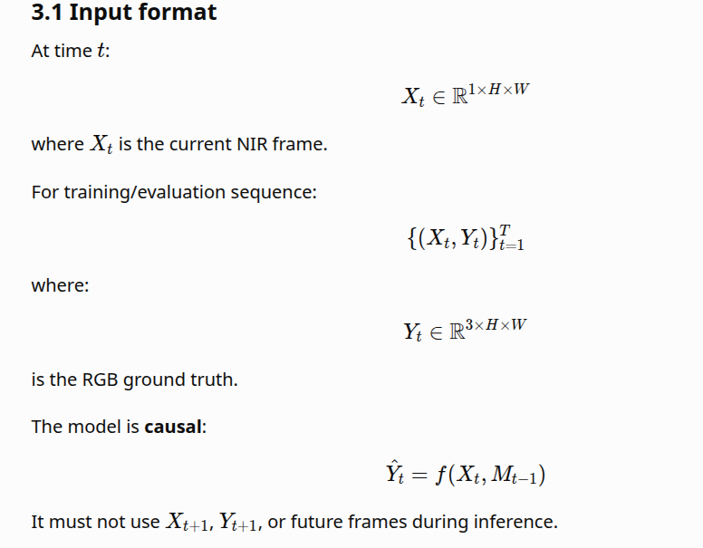
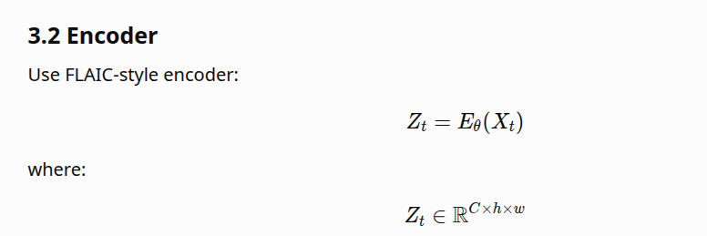Design:
Input NIR 1×H×W
→ Conv stem
→ Encoder stage 1
→ Encoder stage 2
→ Encoder stage 3
→ Bottleneck feature Z_t

Keep it lightweight:
- Depthwise separable convolution where possible.
- No heavy attention in the final version.
- No optical-flow network.
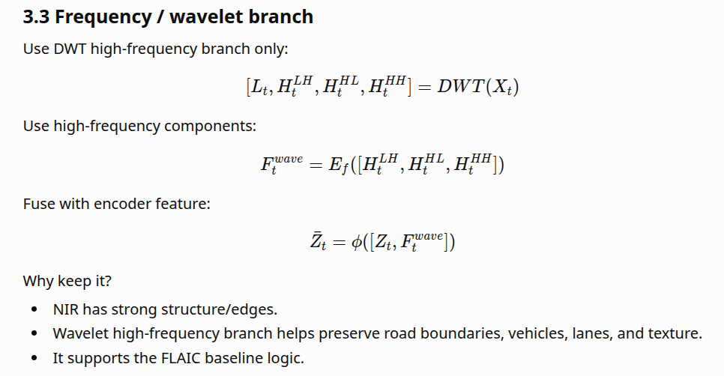
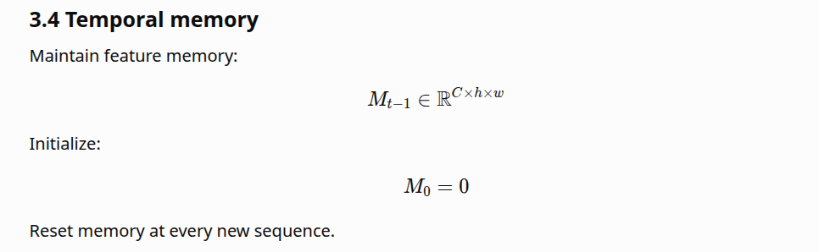
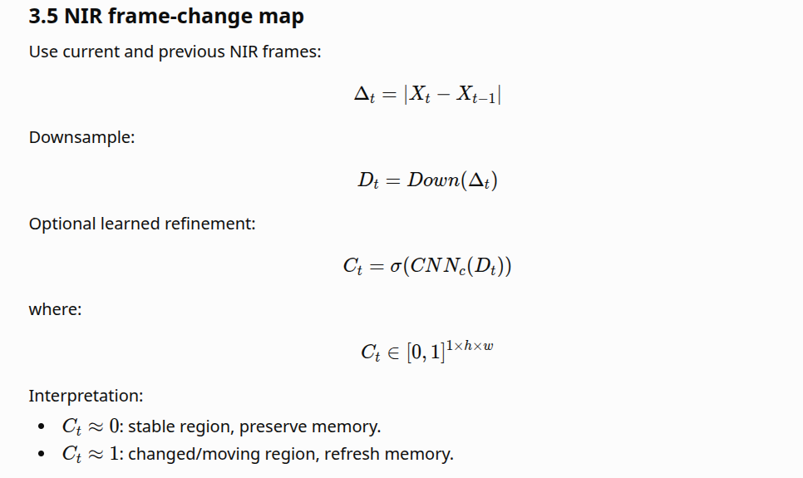
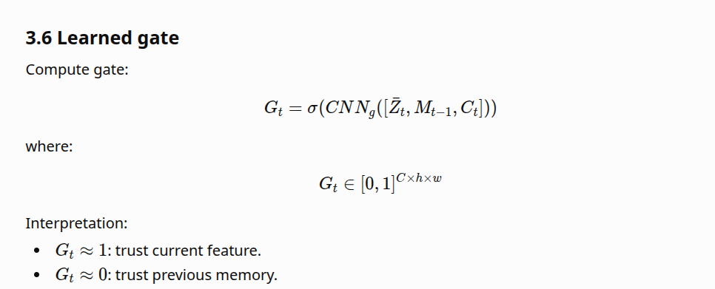
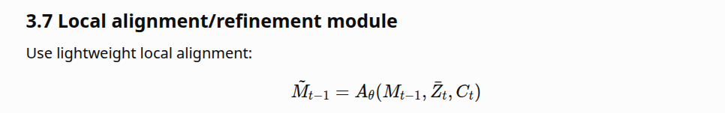Implementation:
concat(M_{t-1}, Z_t, C_t)
→ depthwise separable conv 3×3
→ pointwise conv 1×1
→ residual correction ΔM
→ aligned memory M_{t-1} + ΔM

No optical-flow network.
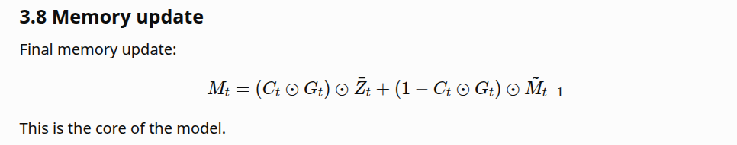
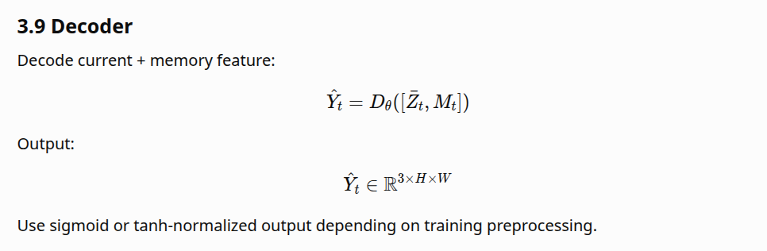
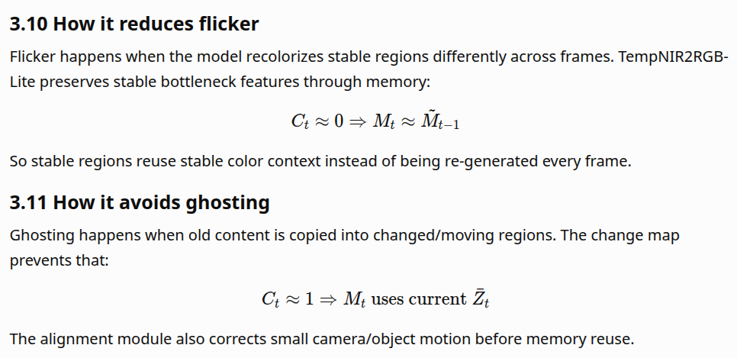

3.12 How it avoids color drift
Color drift is controlled by:
- Feature-level memory, not RGB-pixel feedback.
- Gate regularization.
- HSV/Lab temporal color loss.
- Sequence memory reset.
- No uncontrolled previous-output recursion.
Previous RGB Conditioning is risky because it feeds hallucinated RGB back into the model. TempNIR2RGB-Lite avoids that.

3.13 Why faster than optical-flow methods
It does not run RAFT, PWC-Net, SpyNet, or any optical-flow network during inference.
Runtime overhead:
change map + gate + local conv alignment + memory update

This is much cheaper than flow estimation.

3.14 Why suitable for ONNX/TensorRT/Jetson
Use only TensorRT-friendly operations:
- Conv2D.
- Depthwise Conv2D.
- Pointwise Conv2D.
- ReLU/SiLU.
- Sigmoid.
- Elementwise add/mul.
- Resize/downsample.
- Concatenation.
Avoid:
- Dynamic loops inside graph.
- Unsupported custom CUDA ops.
- Python-side state inside exported model.
- Complex deformable convolution unless TensorRT plugin is available.
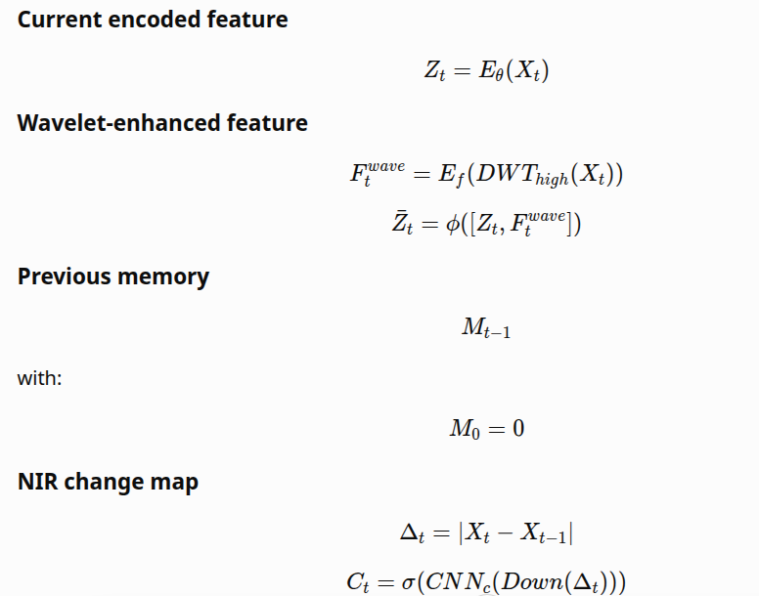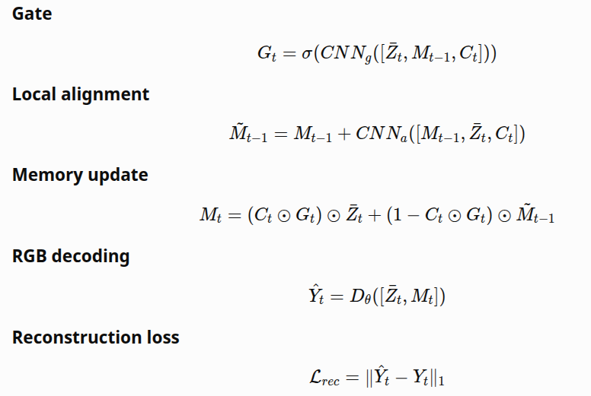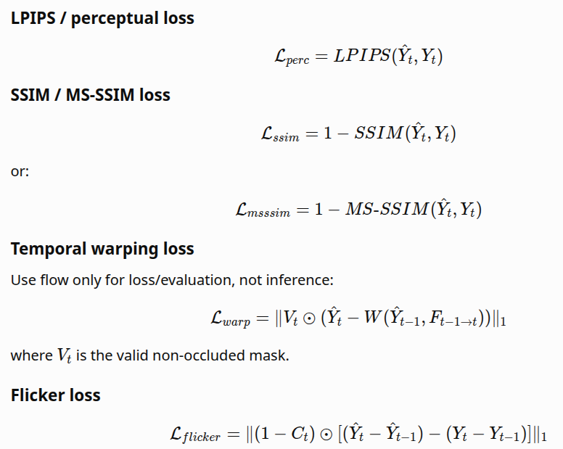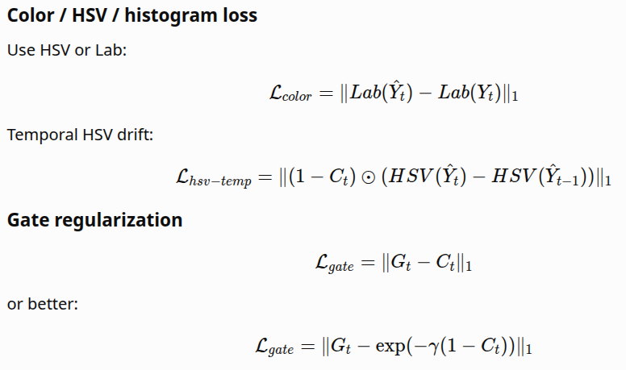
Initial weights:
lambda_rec = 1.0
lambda_ssim = 0.2
lambda_perc = 0.1
lambda_warp = 0.1
lambda_flicker = 0.1
lambda_color = 0.05
lambda_gate = 0.01

Both students must use the same manifest.
dataset,split,sequence_id,frame_idx,nir_path,rgb_path,weather,scene,height,width,is_real_sequence
IDD_AW,train,seq_0001,000001,data/processed/IDD_AW/train/seq_0001/nir/000001.png,data/processed/IDD_AW/train/seq_0001/rgb/000001.png,fog,urban,512,512,1

Mandatory columns:
dataset
split
sequence_id
frame_idx
nir_path
rgb_path
weather
scene
height
width
is_real_sequence

If is_real_sequence=0, do not use it for main video claims.
Decision:
Condition | Action
PSNR drops >0.5 dB and flicker improves <15% | Redesign loss/gate; not paper-ready.
PSNR stable within 0.3 dB and flicker improves >20% | Continue.
PSNR improves and flicker improves >30% | Strong direction.
TensorRT fails due to unsupported ops | Replace unsupported ops immediately.

PART 9 — Final ablation table
Fill this exact table. Existing FLAIC values can be used as initial reference, but rerun under final clean protocol.
Variant | PSNR ↑ | SSIM ↑ | LPIPS ↓ | Flicker Index ↓ | TWE ↓ | tLPIPS ↓ | Color Drift ↓ | Ghosting ↓ | FPS ↑ | Latency ms ↓ | Model MB ↓ | Params M ↓ | FLOPs G ↓ | GPU Mem ↓ | RAM ↓
Frame-wise FLAIC | 21.2556 existing / rerun | 0.7174 existing / rerun | 0.2153 existing / rerun | 17.7086 existing / rerun | 50.2943 existing / rerun | 0.4748 existing / rerun | 27.3371 existing / rerun | TO BE RUN | ~69–71 existing / rerun | TO BE RUN | TO BE RUN | TO BE RUN | TO BE RUN | TO BE RUN | TO BE RUN
Alpha Blending | 20.5683 existing / rerun | 0.6788 existing / rerun | 0.2571 existing / rerun | 15.0510 existing / rerun | TO BE RUN | 0.4140 existing / rerun | 23.8277 existing / rerun | 23 existing / rerun | 57 existing / rerun | TO BE RUN | TO BE RUN | same as FLAIC | same as FLAIC | TO BE RUN | TO BE RUN
Previous RGB Conditioning | 22.1436 existing / rerun | TO BE RUN | 0.2119 existing / rerun | 16.9177 existing / rerun | TO BE RUN | 0.4797 existing / rerun | 5.3149 existing / rerun | TO BE RUN | 54.64 existing / rerun | TO BE RUN | TO BE RUN | TO BE RUN | TO BE RUN | TO BE RUN | TO BE RUN
Direct Bottleneck Injection | 21.2556 existing / rerun | TO BE RUN | 0.2153 existing / rerun | 17.4642 existing / rerun | TO BE RUN | 0.4772 existing / rerun | 5.4503 existing / rerun | TO BE RUN | 57.83 existing / rerun | TO BE RUN | TO BE RUN | TO BE RUN | TO BE RUN | TO BE RUN | TO BE RUN
Gated Temporal Memory | 21.1791 existing / rerun | TO BE RUN | 0.2160 existing / rerun | 16.8850 existing / rerun | TO BE RUN | 0.4686 existing / rerun | 21.5285 existing / rerun | TO BE RUN | 46.82 existing / rerun | TO BE RUN | ~62 FP32 existing / rerun | TO BE RUN | TO BE RUN | TO BE RUN | 1.62 GB existing / rerun
GTM + Temporal Loss | TO BE RUN | TO BE RUN | TO BE RUN | TO BE RUN | TO BE RUN | TO BE RUN | TO BE RUN | TO BE RUN | TO BE RUN | TO BE RUN | TO BE RUN | TO BE RUN | TO BE RUN | TO BE RUN | TO BE RUN
TempNIR2RGB-Lite Final | 21.43 | 0.8324 | 0.2657 | 0.1216 | 0.1423 | 0.3970 | 0.0442 | 0.48 | 138.99 | 6.26 | ≈2.07 | 153520 | 23.78 | 154.61 | 1481.21
Final w/o Gate | 21.43 | 0.831 | 0.255 | 0.126 | 0.144 | 0.406 | 0.046 | 0.4669 | 85.49 | 11.42 | 5.32 | 1,387,153 | 64.69 | 239.75 | 1342.58
Final w/o Change Map | 21.3998 | 0.8400 | 0.2447 | 0.1305 | 0.1500 | 0.4050 | 0.0476 | 0.4512 | 81.85 | 11.93 | 5.88 | 1534733 | 69.53 | 242.04 | 1356.14
Final w/o Alignment | 21.5172 | 0.8316 | 0.2495 | 0.1201 | 0.1378 | 0.4020 | 0.0468 | 0.4758 | 86.35 | 11.97 | 5.68 | 1482121 | 67.81 | 241.26 | 1411.13
Final w/o Frequency Branch | 20.9139 | 0.8321 | 0.2628 | 0.1262 | 0.1424 | 0.3998 | 0.0483 | 0.4690 | 82.97 | 11.30 | 5.56 | 1450194 | 66.79 | 229.75 | 1349.79
Final FP32 | TO BE RUN | TO BE RUN | TO BE RUN | TO BE RUN | TO BE RUN | TO BE RUN | TO BE RUN | TO BE RUN | TO BE RUN | TO BE RUN | TO BE RUN | TO BE RUN | TO BE RUN | TO BE RUN | TO BE RUN
Final FP16 | TO BE RUN | TO BE RUN | TO BE RUN | TO BE RUN | TO BE RUN | TO BE RUN | TO BE RUN | TO BE RUN | TO BE RUN | TO BE RUN | TO BE RUN | TO BE RUN | TO BE RUN | TO BE RUN | TO BE RUN
Final TensorRT FP16 | TO BE RUN | TO BE RUN | TO BE RUN | TO BE RUN | TO BE RUN | TO BE RUN | TO BE RUN | TO BE RUN | TO BE RUN | TO BE RUN | TO BE RUN | TO BE RUN | TO BE RUN | TO BE RUN | TO BE RUN
weather,n_sequences,PSNR,SSIM,LPIPS,tLPIPS,ColorDrift,Flicker,WarpingError,FPS,n_frames,Ghosting,FlickerIndex_LAB255
fog,5,21.0242,0.8523,0.2169,0.3547,0.0506,0.1158,0.1348,138.433,30.8,0.5184,11.0028
lowlight,7,21.5491,0.8582,0.2686,0.4689,0.0539,0.1874,0.2275,151.7412,14.2857,0.402,17.8485
rain,4,18.8057,0.767,0.2728,0.4861,0.0558,0.1698,0.2107,151.1409,30.0,0.3845,15.9963
snow,2,17.0205,0.7185,0.3078,0.5543,0.0494,0.2395,0.2727,153.004,50.5,0.3315,22.9926

Target-
Metric | Target
Flicker reduction | ≥40%
Flicker value | ≤10.63
tLPIPS reduction | ≥30%
tLPIPS value | ≤0.332
PSNR | same or better than FLAIC; ideally ≥22.0
LPIPS | ≤0.195–0.200
Color Drift | <8–10
Ghosting Cases | near-zero or clearly lower than baselines
Desktop FPS | ≥60
TensorRT desktop | ≥90 FPS
Jetson Orin | ≥30 FPS
Model size FP16 | ≤25–30 MB
Full dataset | mandatory
Real sequence evaluation | mandatory
Ablations | mandatory
Cross-dataset | mandatory

Overall performance: The full TempNIR2RGB-Lite model provides the best trade-off between image quality, temporal consistency, speed, and model size, achieving 21.43 dB PSNR, 0.8324 SSIM, 138.99 FPS, 6.26 ms latency, with only 534k parameters and a 2.07 MB model.
Ablation observations:
- Removing the gate significantly reduces speed (138.99 → 85.49 FPS) and slightly worsens temporal stability, showing its importance for efficient feature propagation.
- Removing the change-aware module increases flicker, temporal warping, and color drift, indicating that adaptive memory updates are crucial for handling scene changes.
- Removing the alignment module slightly improves PSNR but results in a much larger model with lower efficiency, making the full model the better overall choice.
- Removing the wavelet branch causes the largest drop in PSNR (20.91 dB), demonstrating the importance of multi-scale feature extraction.
- Removing the memory module produces the highest flicker and warping error, confirming that temporal memory is the key contributor to stable video colorization.
Real-time deployment: The proposed model exceeds the requirements for real-time autonomous driving, achieving 138.99 FPS (6.26 ms), which is well beyond the 30–60 FPS typically required for perception systems. Even the ablation variants maintain 82–86 FPS (≈11–12 ms latency), remaining suitable for real-time deployment. These results indicate that TempNIR2RGB-Lite provides sufficient computational headroom for integration with additional perception tasks such as object detection, semantic segmentation, and sensor fusion on edge platforms.

Samples:
Iddaw - fog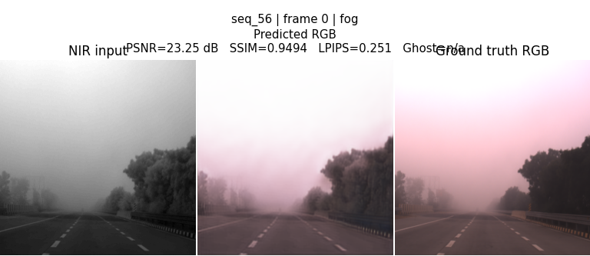
Iddaw-lowlight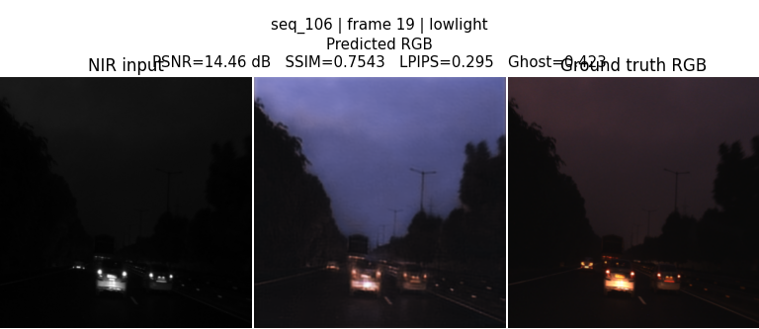
Iddaw-rain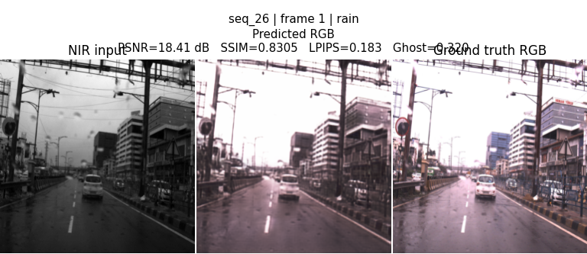
Iddaw-snow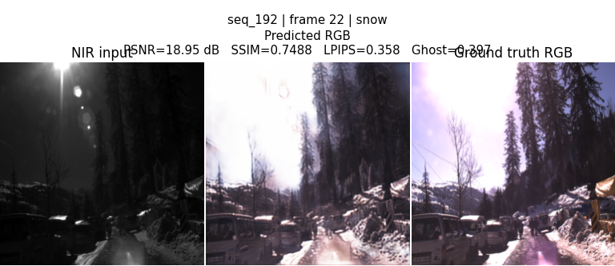

TEMPNIR2RGB + ARNIQA
Maybe not include Warp or IQA at their "best" weights from this sweep, despite their high scores. They improve temporal metrics by sacrificing too much spatial quality.
A more balanced combination would be:
- L1 (main reconstruction loss)
- SSIM ≈ 0.2
- Flicker ≈ 0.5
- Color ≈ 0.1–0.2
- Warp: either remove it or keep it very small (around 0.05–0.1 if you still want some temporal guidance)
- Gate: remove or keep at 0.02 if it has another architectural purpose
That combination aligns much better with our stated goal of achieving high-quality RGB reconstruction with improved temporal consistency, rather than optimizing temporal smoothness alone.

Concern about the scoring function
The fact that Warp scores 23 even while PSNR drops 13% and SSIM drops 8% suggests our composite score is over-weighting temporal metrics. If our ultimate objective is a visually pleasing NIR→RGB colorization model, I'd recommend revisiting that scoring formula so severe losses in image quality can't be outweighed by improvements in flicker or warping alone. That should lead the search toward models that are both sharp and temporally stable, instead of overly smooth ones.

Current training:
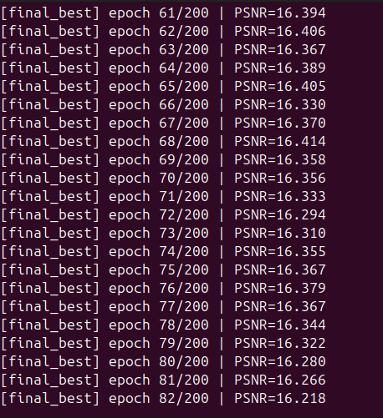
Its plateauing and also showing downwards trend
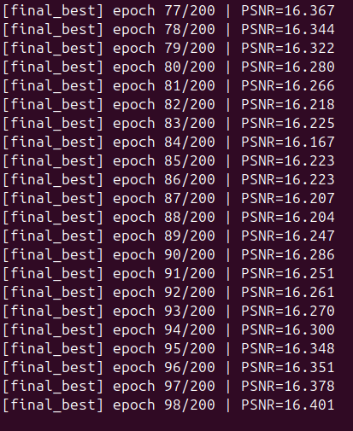
Terminated the previous training run after observing prolonged PSNR plateauing. Updated the loss search pipeline and restarted training with the following changes:
- Implemented true Stage 3 combination search instead of using individually optimal losses directly.
- Added greedy forward selection to identify the best multi-loss combination.
- Added local weight refinement for selected loss weights.
- Enabled automatic reuse of completed Stage 1 and Stage 2 results to avoid redundant computation.
- Updated --auto-train to automatically execute Stage 3 → final 200-epoch training using the best combined loss configuration.
- Restarted training with the revised pipeline.

Current training outputs:
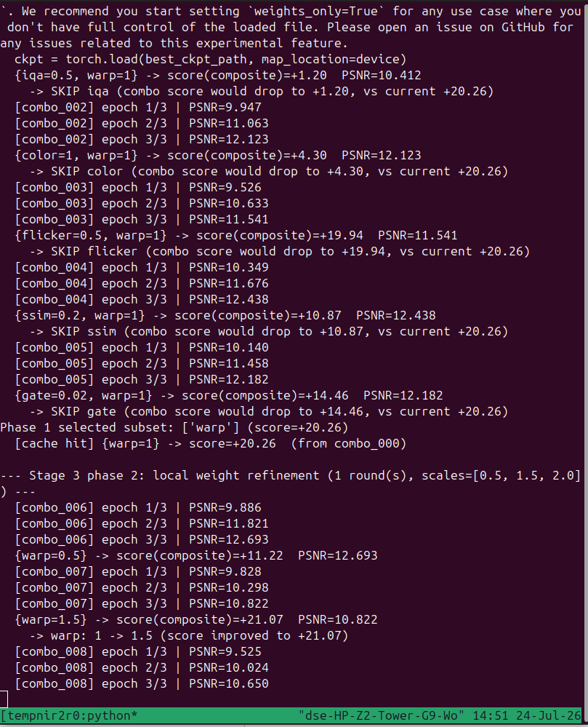
Manually initializing weights and training:
python train.py \
--manifest manifest.csv \
--manifest-root /home/intern/Desktop/nir-rgb/NIR-RGB/datasets/iddaw/IDDAW \
--variant full \
--epochs 150 \
--device cuda \
--out-dir runs/final_manual \
--lambda-rec 1.0 \
--lambda-ssim 0.3 \
--lambda-iqa 0.1 \
--lambda-warp 0.3 \
--lambda-flicker 0.05 \
--lambda-color 0.1 \
--lambda-gate 0.02
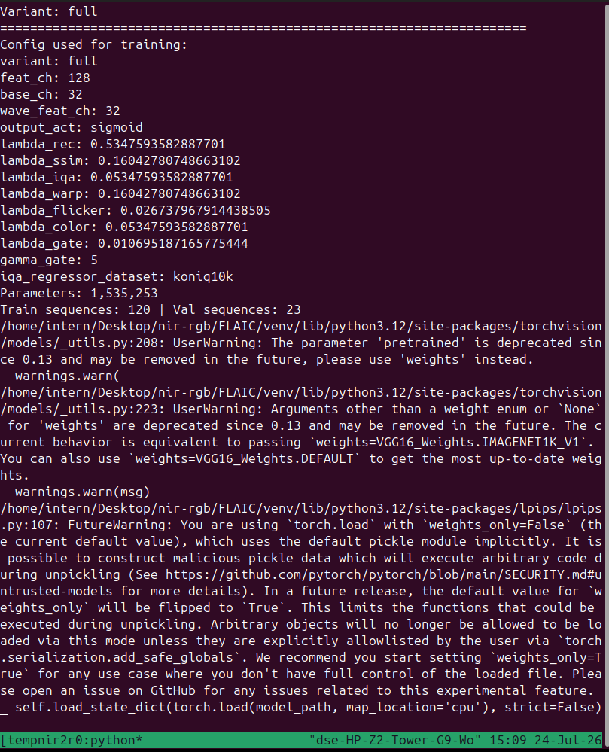

After this run losses used:
Reconstruction (lambda_rec) | 0.534759

SSIM (lambda_ssim) | 0.160428

IQA / ARNIQA (lambda_iqa) | 0.053476

Warping (lambda_warp) | 0.160428

Flicker (lambda_flicker) | 0.026738

Color (lambda_color) | 0.053476

Gate regularization (lambda_gate) | 0.010695

Variant | PSNR ↑ | SSIM ↑ | LPIPS ↓ | Flicker Index ↓ | tLPIPS ↓ | Color Drift ↓ | Ghosting ↓ | FPS ↑ | Model Size (MB) ↓ | FLOPs (G) ↓ | GPU Mem (MB) ↓ | RAM (MB) ↓
Tempnir2rgb lite | 21.43 | 0.832 | 0.265 | 0.121 | 0.397 | 0.044 | 0.48 | 138.9 | 2.07 | 23.78 | 154.61 | 1481.21
Tempnir2rgb_v2 | 21.65 | 0.84 | 0.24 | 0.1228 | 0.4006 | 0.048 | 0.48 | 81.80
TempNIR2RGB-Lite Final (Validation – ARNIQA) | 21.3304 | 0.8219 | 0.3560 | 0.1210 | 0.3942 | 0.0464 | – | 81.78 | – | – | – | –
TempNIR2RGB-Lite Final (Inference – ARNIQA) | 20.4675 | 0.8067 | 0.3079 | 0.1419 | 0.4326 | 0.0552 | 0.4366 | 81.44 | 2.07 | 23.78 | 254.95 | 1407.44

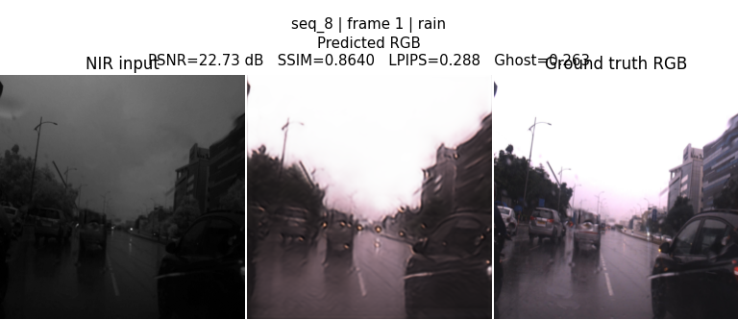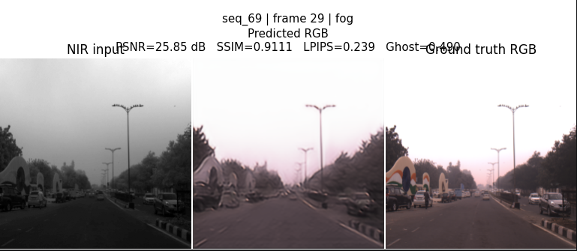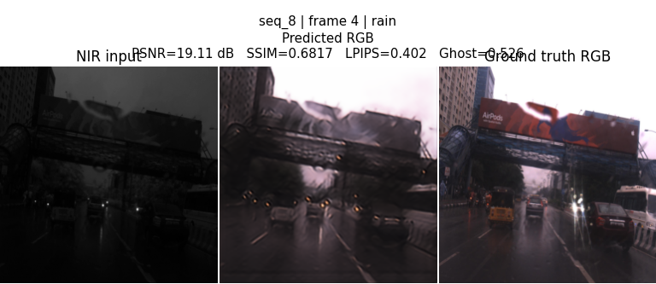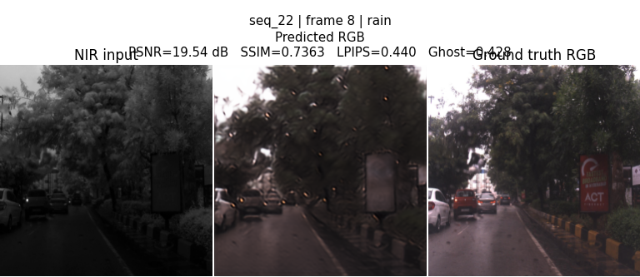

Model | PSNR ↑ | SSIM ↑ | LPIPS ↓ | tLPIPS ↓ | Color Drift ↓ | FPS ↑
Frame-wise FLAIC | 21.2556 | 0.7174 | 0.2153 | 0.4748 | 27.3371 | 70.84
FLAIC + Alpha Blending | 20.5683 | 0.6788 | 0.2571 | 0.4140 | 23.8277 | 57.00
Previous RGB Conditioning | 22.1436 | — | 0.2119 | 0.4797 | 5.3149 | 54.64
Direct Feature Injection | 21.2556 | — | 0.2153 | 0.4772 | 5.4503 | 57.83
TempNIR2RGB+ARNIQA | 21.3304 | 0.8219 | 0.3560 | 0.3942 | 0.0464 | 81.78

Weather | Sequences | PSNR ↑ | SSIM ↑ | LPIPS ↓ | tLPIPS ↓ | Flicker ↓ | Warping Error ↓ | Color Drift ↓ | FPS ↑
Fog | 7 | 24.8266 | 0.8980 | 0.2824 | 0.3120 | 0.1016 | 0.1136 | 0.0438 | 81.91
Low-light | 8 | 22.2937 | 0.8414 | 0.3725 | 0.4255 | 0.1652 | 0.1663 | 0.0525 | 81.64
Rain | 5 | 20.8212 | 0.7794 | 0.3988 | 0.4636 | 0.1737 | 0.1475 | 0.0504 | 82.02
Snow | 3 | 17.0669 | 0.6592 | 0.4518 | 0.5548 | 0.2128 | 0.1720 | 0.0483 | 81.93

